## Introduction

The purpose of this document is to establish the existence or severity of anti-competitive effects of the voucher scheme for VHCN envisioned by the Cyprus authorities.

Before diving into the economic arguments that could arise in such situations, we will begin by first giving a brief description of the Cyprus market, and the players involved in, as well as describe some economically important details of the voucher scheme.

In the second section we will describe the Cyprus authorities intended function for the use of vouchers and why vouchers may be the appropriate instrument.

Finally we will dive into a several economic issues where the voucher scheme could potentially have an impact on the Cypriot telecommunications market. We will evaluate the risk that they pose towards strengthening of market power of the incumbent firm, or whether the scheme might create opportunities for other market players. Some measures the Cypriot authorities could envisage will be discussed, when a risk to market balance emerges.

## Fixed broadband market structure

The Cyprus market for fixed broadband is characterized by a large incumbent who is a state-owned enterprise, Cyta and three smaller firms which have gradually gained a foothold in the market, Primetel, EPIC, Cablenet. The annual size of the Cyprus fixed broadband market, in terms of market value, is 124 million euros. The subsidy will be a total amount of 10 million euros. As the scheme will be rolled out over a three year period the aid intensity will actually be 2.7% of the market value over the relevant period.

|  |  |  |  |  |  |  |
| --- | --- | --- | --- | --- | --- | --- |
|  | Retail market shares[1] | | | | | |
|  | Cablenet | Cyta | Epic | Primetel | Total market value | HHI[2] |
| ***Fixed*** | 27% | 48% | 9% | 16% | 124M | 3370 |

As can be seen on the above table, Cyta – the incumbent – captures almost 50% of market shares. As such, it represents the biggest potential presence of market power. Therefore, it should be considered that if measures reinforce Cyta’s position they should be considered as increasing monopoly power; if they weaken the Cyta’s position they should be seen as pro-competitive.

EU wide publicly available information on market shares as percent of total sales is quite limited but for the purpose of comparing we use simply subscriber market shares in France[3] and Greece.[4]

|  |  |  |  |  |  |  |
| --- | --- | --- | --- | --- | --- | --- |
| France/number of subscribers/Q3 2020 | Orange (incumbent) | SFR | Bouygues Telecom | Iliad (Free) | Other | HHI |
| Fixed BB | 40% | 21% | 13.4% | 22% | 4% | 2720.56 |
| Mobile BB | 30.3% | 24% | 16.4% | 18% | 11.3% | 2214.74 |

|  |  |  |  |  |  |
| --- | --- | --- | --- | --- | --- |
| Greece Market Share 2020 | Cosmote(OTE) | Forthnet | Vodafone Greece | Greece other | HHI |
| Fixed BB(Greece) | 49.6% | 13.2% | 22.7% | 14.4% | 3357.05 |

|  |  |  |  |  |
| --- | --- | --- | --- | --- |
| Malta Market Share[5] | GO | Melita | Other | HHI |
| Fixed BB(Greece) | 65% | 34% | 1% | 5,382.00 |

As we can see from the HHI index in France, the fixed and mobile markets in France are subject to significantly more competition. However, perhaps a more comparable country is Greece, and as can be seen above, for the fixed broadband, the HHI index is very close and though there is a strong incumbent in place, the position of the incumbent is in line with countries in similar positions. Finally, if we compare to another island country whose population is also much closer to Cyprus, we see that Cyprus is much more competitive.

## The Cypriot voucher scheme

The voucher scheme envisioned by the Cypriot authorities aims to increase the demand side for VHCN by directly subsidizing the consumer. More specifically, only consumers that are not currently connected to a VHCN will be eligible. The amount intended per subscriber is 120 euros for a period of 1 year. Each consumer can only receive a single such voucher. For example, if the monthly price of a given plan is advertised at 20 euros, a consumer eligible to the voucher will end up paying 20-(120/12)=10 euros a month. It has to be noted that the costs for the operators also include the connection of the building (and possibly the in-house cabling) to bring the required speeds to the household. The consumer will not “see” this cost, but it is a significant share of the burden for the operators. The connection costs for houses passed vary from Euro 112 to Euro 182 in Cyprus, depending on operator charges. The real costs are likely higher in certain cases. The total number of beneficiaries foreseen is 82,000 or 23% of Cypriot households, for a total of 10 million (M hereafter) euro subsidy over the period 2022-2025. The practicalities of the voucher will be that the consumer subscribes, the operator establishes the connection, the speed is tested; if it meets the required speed[6], then the operator can redeem the amount of the voucher (120 euros) from the competent authority.

The voucher amount has been set as a fixed amount per household and covers the set-up costs of households as well as part of the subscription fees. The amount per voucher is the same irrespective of the operator. It has been evaluated that the voucher will result in subsidizing less than 50% of the eligible costs (set-up costs and subscription fees for 12 months) of any of the currently available providers. The amount of subsidy therefore complies with the limits laid down in paragraph 191 of the draft EU Broadband Guidelines. The voucher scheme in Cyprus will extend over a period of just over two years. However, Cypriot consumers eligible to the voucher will see their monthly subscription costs partially subsidized for exactly one year.

## The intended function for the use of vouchers: boost demand

The intended goal by the Cyprus authorities for this voucher scheme is to increase subscription rates to fast broadband in Cyprus. According to the Digital Economy and Society Index 2021[7], Cyprus already has a close to 100% coverage of NGA broadband (i.e., speeds achieving 30Mbps) which is above the EU average of 87%, and 26% coverage for very fast broadband which, by contrast, is below the EU average of 59%. It is important to note that Cyprus lags behind on the take-up of these services: 3% of households have subscriptions to at least 100Mbps fixed broadband compared to 34% of European average, and fewer than 0.01% have subscriptions to at least 1Gbps compared to 1.3% EU average. The reasons for the low demand for higher speeds are manifold. The digital literacy is lower than in other Member Stets (according to DESI, Cyprus has a 45% digital literacy vs 56% EU average). Furthermore, prices on the Cypriot market are well above EU average, which creates an impediment to up-take. The appropriateness of demand side vs supply side policies depends on the conditions of the market. A supply side measure such as subsidizing infrastructure or co-financing fixed costs of operators is the appropriate measure to cover underserviced areas of market failure. On the other hand, where supply is available, but consumer demand remains low, then a demand side measure would be most appropriate. Cyprus finds itself in the second scenario, where services are available but consumers are not opting for higher speeds.

As such, since Cyprus already has a relatively high coverage, the Cypriot authorities have deemed a demand side measure to be most appropriate for increasing the demand and services delivered to households.

## Addressing potential market issues associated with the use of subsidies

In the following section we will explore the main elements which might create market distortion. Indeed, several elements might have an impact on the way a demand side voucher affects the relative market position of the current operators.

Since the voucher scheme can only be used to get at least 200 Mbps download, up-gradable within three working days to a 1Gbps download and 250 Mbps upload speed connection, the scheme is unlikely to distort existing demand in favour of lower speed services. The scheme can be used to upgrade existing connections. More importantly, the voucher should be used to improve the subscriber’s connectivity. Conditioning eligibility on the highest speed (1Gbps for Cyprus) may give some consumers the incentive to change plan not because they have a need (or willingness to pay) for it, but just for the sake of using the voucher. By setting the threshold for eligibility at a lower level (200Mbps), which is what the Cypriot authorities propose, the consumer surplus generated by the voucher scheme is expected to be greater. Indeed, the beneficiary households will benefit from the 1Gbps connection if they so wish in the future, however, as the need of the household might be lower at the moment of subscription this policy of subsidizing 200 Mbps will widen the potentially interested stakeholders.

## Bundling

Bundling is defined as the practice of offering to consumers a lower price for a certain good when it is bought with other goods versus when it is bought individually. In the telecoms market this is generally referred to as “double play” (covering fixed and TV subscription) or “triple play” (covering fixed, mobile and TV subscription). A natural cause for concern about a voucher scheme on telecoms services is that an operator who is strongly situated in numerous markets can use their position to further gain market share in the other markets through bundling.

|  |  |  |  |  |  |  |
| --- | --- | --- | --- | --- | --- | --- |
|  | Retail market shares[8] | | | | | |
|  | Cablenet | Cyta | Epic | Primetel | Total market value | HHI[9] |
| ***Mobile*** | 1% | 51% | 39% | 9% | 218M | |  | | --- | | 4204 | |  | |  | |
| ***Fixed*** | 27% | 48% | 9% | 16% | 124M | 3370 |
| ***Tv Services*** | 13% | 69% | 0% | 18% | 30M | |  | | --- | | 5254 | |

As can be seen above, the four providers have heterogeneous capabilities in the various market segments. Specifically, Cablenet specializes in fixed broadband (27%) and has low presence in mobile (1%) and TV services (13%). In comparison, Epic has a strong presence in the Mobile Market (39%) but limited presence in Fixed (9%) and TV services (0%).

In the Cypriot case, if Cyta or Pimetel were to bundle TV services with fixed broadband, they could potentially attract Epic subscribers. A similar reasoning applies to Cablenet and mobile subscription services.

However, the cause for concern with bundling is limited due to the current structure of the market. Bundled services remain popular with a slight increase of fixed broadband subscriptions as part of a bundle to 78%, in comparison with 73% last year.[10] Of these bundles, 61% consists of fixed telephony and broadband access. 0nly 25% of bundled connections include IP/cable TV access. As such, it seems that bundling in the Cypriot environment does not confer large market power (as only 20% of the market is bundled with TV services).

Furthermore all four operators in Cyprus can offer all services (fixed, mobile and TV connection). As such the voucher scheme would have a limited distorting impact.

Expected impact of the scheme according to criterion 1: Bundling

## Pricing

In general, Cyprus has the highest broadband prices in Europe.

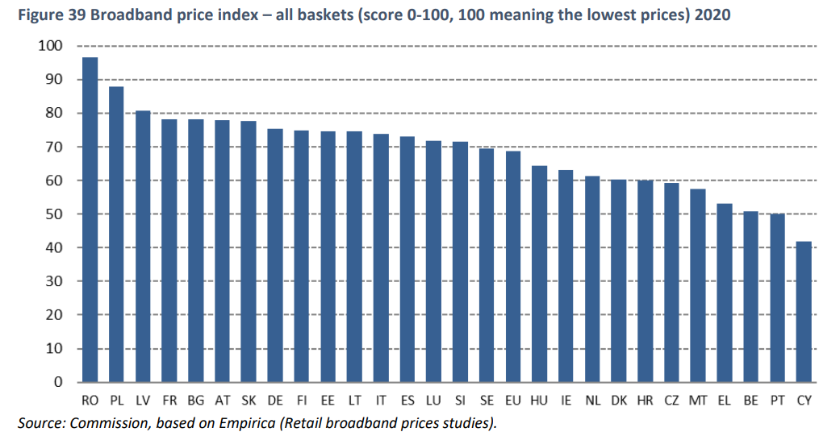[11]

A possible cause for concern related to a voucher scheme is that the providers may use it as an opportunity to increase prices. Indeed, consumers may make purchasing decisions based on cutoffs of monthly expenditures. For example, consumers may only consider purchases which do not exceed a certain proportion of their income. This pattern on the demand side i.e., making inelastic choices for cheap products and relatively more elastic for expensive products could give suppliers a strong incentive to increase their lower priced products.

To ensure that this does not occur, the Cyprus authority will guarantee that the four operators will not engage in price discrimination between consumer groups. Therefore the prices offered for a given plan by a given operator is the same for all consumers, regardless of whether they benefit from the voucher scheme or not. Said differently, voucher recipients should not be charged a higher price for the same services.

The voucher will be of a fixed and pre-defined amount (i.e., a lump-sum subsidy) and not a percentage of the price of the eligible costs. Otherwise, the scheme could render the demand relatively more inelastic than before the introduction of the scheme, which could give the operators an incentive to increase prices. This would be counter-productive given that Cyprus prices are already significantly above the EU average. If the voucher is of a fixed amount, operators will still have the incentive to compete on the economic terms of their respective offers.

## Cablenet is the provider which has an advantageous starting position in terms of houses passed. The installation base of the cable network is currently higher than that of the equivalent fibre network from other operators. This means Cablenet has lower costs to reach the required speeds under the scheme than the other operators. As such a higher portion of the voucher scheme will go directly into recuperating operational costs rather than capital costs. Therefore, it is not the incumbent who will disproportionately benefit but potentially its competitor Cablenet. Given the above elements there is a risk that Cablenet would disproportionately benefit from the voucher scheme. Indeed, the vouchers can only be used in areas where the households are already “passed” by gigabit capable infrastructure. The fibre network in Cyprus is still relatively small, whereas Cablenet has an extensive DOCSIS network. Currently only DOCSIS 3.0 is offered in Cyprus. As such the voucher scheme would create an incentive to Cablenet to up-grade to DOCSIS 3.1, which would make its offer eligible speeds for the voucher. There is therefore a risk that Cablenet would get a share of the vouchers which is above its current market share. We see this as a benefit to the market rather than a risk, as it would strengthen the position of a challenger to the incumbent. Furthermore it would create an incentive for Cablenet to start offering state of the art technology (DOCSIS 3.1) in Cyprus which is currently not available to consumers.

Expected impact of the scheme according to criterion 2: Pricing

## Lock-in

The voucher foresees a cost rebate for the first 12 months of subscription. The voucher is non-transferable. As such there is an incentive for the consumer to stay with the operator where the voucher is redeemed. There is no legal lock-in clause under the voucher, according to Cyprus law consumers will still be allowed to switch operators. By making the voucher non-transferable the risk to the operator incurring the cost of first connection is mitigated. The consumer has an incentive to stay with the cheaper offer from the voucher offer. However, there is no obligation. If the consumer switches to a cheaper offer from another operator then the scheme would have had the effect to reduce prices in Cyprus, which would overall be beneficial, while making gigabit networks available to more households.

The anti-competitive effects of this kind of lock-in are expected to be limited because the initial service provider will incur a significant fixed cost to connect the household to the network. The Cyprus authorities have purposefully designed the voucher in this way: it is of sufficiently low value to enable the initial operator to recuperate the fixed cost without subsidizing operating costs. This limits the risk that the voucher scheme affects prices, and it makes it in accordance with the EU broadband guidelines (that allow for two-year lock in).

We therefore do not foresee that this soft “lock-in” will have a significant market impact.

Expected impact of the scheme according to criterion 3: Lock in

## Wholesale market

Ordinarily the presence of a two-tiered market (in the sense of retail and wholesale) represents a market power risk. This is because a subsidy which is meant to target one part of the supply chain may in fact affect another part. In general the effect may be funneled to a part of the supply chain which faces the least competition. As such, it is important to establish why this will not occur on a particular intervention.

The wholesale market in Cyprus telecoms is a duopoly between Cyta and Cablenet for fixed broadband and a duopoly between Cyta and Epic for mobile. However, wholesale market shares are subject to change as Cyta, Cablenet and Epic are currently investing in new infrastructure with the aim of increasing connectivity to 90% of premises by 2026. Epic has specifically secured 19M from the European Investment bank which will double the number of homes which it can connect to fiber (from 25k to 50k homes).

The size of Mobile and Fixed wholesale markets are, respectively, 26M and 20M Euros. [12]

|  |  |  |  |  |
| --- | --- | --- | --- | --- |
|  | Wholesale market share[13] | | | |
|  | Cablenet | Cyta | Epic | Primetel |
| ***Mobile*** | 0% | 68.6% | 29.6% | 1.8% |
| ***Fixed*** | 0% | 40% | 2% | 58% |

We expect the voucher scheme not to alter the current negotiating positions of the four providers because the subsidy is given to consumers. That is, since the voucher scheme is a demand side subsidy, the relatively low competition in the wholesale market will not affect the retail market. As such this subsidy is of low risk for the re-distribution of profits among firms.

Additionally, the Cypriot authorities have historically obliged Cyta and other wholesalers to provide equitable conditions for the use of their infrastructure. In particular, the NRA has full regulatory authority to limit the prices that Cyta can charge when selling wholesale access. This is in accordance with economic theory[14].

In conclusion, the wholesale structure of the market is unlikely to be negatively affected by the voucher scheme.

Expected impact of the scheme according to criterion 4: Whole sale prices

* 1. Competition

The Cypriot telecoms market has a double edged sword to it in the sense that the incumbent, also offers some of the best prices in the market, as can be seen below. Cyta has the lowest monthly cost of all providers and is the only one who offers to construct a connection to currently poorly connected houses.

This means that if Cyta increases its market share, we can expect the prices to decrease. Which means that in the case of Cyprus, monopoly power has rather limited negative effects on market power.

|  |  |  |  |
| --- | --- | --- | --- |
| **Provider(speed)** | **Existing customer annual rate (Euro)** | **New customer annual rate (Euro)** | **Installation for a new customer (Euro)** |
| Cyta(300Mbps)[15][16] | 475.68 | 622.8 | 111.4 |
| Epic(300Mpbs)[17] | 509.88 | 719.88 | 182 |
| Primetel(250Mbps)[18] | 509.88 | 509.88 | 182[19] |
| Cablenet(200Mbps)[20] | 598.8 | 598.8 | 182 |

To get a better sense of these prices, refer to the graph below:

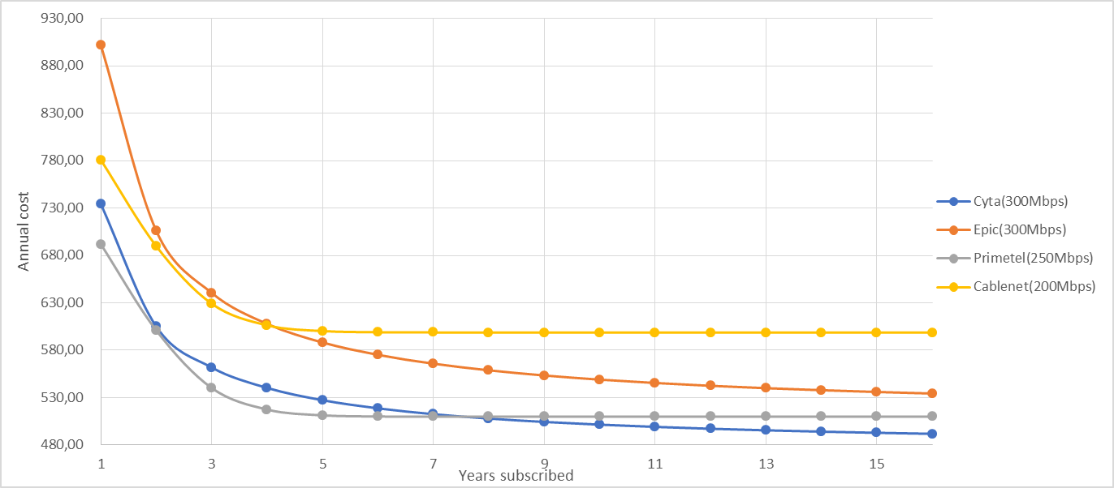

The interpretation of the graph is as follows. Primetel starts off with the most cost competitive package per year but after a certain amount of years, Cyta has a lower average cost to the consumer. On the other hand, Cablenet has the most consistently high prices even after the fixed costs have been paid off.

Additionally, Cyta, being the incumbent, must abide by regulations that other providers do not have to. For example, Cyta must provide access to its network at a regulated price such that it cannot gain undue advantage on its competitors. On the other hand, Cablenet, has a fully private network that is not subject to the same terms. This structure means that Cablenet is likely to capture a higher share of the final retail price, which further weakens the incumbents market power.

As described above then, Cyta, being a strong presence in numerous market segments faces two layers of competition; one layer is on network production from Cablenet, and the other on service provision by all 3 other operators. This means that every part of the supply chain is subject to competitive pressure. We therefore assess the competitive effects to be quite mild or even against the incumbent.

Expected impact of the scheme according to criterion 5: Competition

## Network effect

A boost in demand would immediately decrease the average cost of connecting households to the network. As a concrete example, imagine a distribution point (cabinet) that is connecting to several houses. This distribution point has a fixed cost to operate and the marginal cost of operating each house is relatively small. An increase in demand, especially new connections, is likely to mean that each distribution point connects to more houses. This implies it would allow for a spreading of the fixed cost of operation over a higher number of houses / users. This new lower average cost, is likely to lead to a reduction in prices in a competitive environment. This is a desired effect in Cyprus, where currently retail prices are high in comparison to the EU average.

Therefore the increase in demand generated through the voucher scheme will likely lead to a lowering of subscription costs on the higher speed contracts. This in turn will likely increase the demand for high speed connections even from consumers not benefiting directly from a voucher, as prices come down. As such we expect the scheme to have a positive effect on the competitive environment, and on customer demand beyond the immediate beneficiaries of the scheme.

Expected impact of the scheme according to criterion 6: Network effect

## Technological effects

Under symmetric circumstances a flat subsidy should benefit all players equally. If however there are conditions attached to the subsidy then a differential ability to meet those conditions may imply that the subsidy will not have neutral effects. An especially important feature which will violate the non-neutrality of the subsidy are the heterogenous technological abilities.

The current structure of the market is such that the basic services are DSL and the upgraded services being Cable with very few households having the ultra-fast services (FTTH). The main operator that provides cable is Cablenet with Primetel and Epic slowly developing similar capabilities over fibre. In general, Cyta is used relatively more frequently among users who opt for slower connections.

As such, since consumers choose other providers than the incumbent when opting for faster speeds, it is expected that this trend will continue should the demand rise. Since the voucher is expected and intended to increase the internet speed of consumers, it would also be reasonable to expect that consumers will shift to the “challenger” providers who are more popular for the higher connectivity subscriptions. This implies that the effect of the subsidy on the market will be pro-competitive.

Expected impact of the scheme according to criterion 7: Technology effect

# Conclusion

Although from a theoretical point of view a subsidy has potentially anti-competitive effects, there could be both benefits and low risks in having a demand subsidy on the Cypriot market for fixed broadband.

Firstly, the voucher scheme envisioned by the Cypriot authorities is ambitious. It is ambitious in the sense that a significantly high proportion of Cypriot households will be eligible to the scheme -- 82K out of 350K. It is legitimate in the sense that although the island enjoys a good network coverage, the take-up is low which makes Cyprus lag behind compared to the EU average.

Secondly and importantly, we believe that the voucher scheme presented by the Cyprus authorities will have limited distortive effects on competition. In short, our argument revolves around the observation that the incumbent, Cyta, does not specialize in high speed internet and faces regulatory pressures that do block funneling of the subsidy. Additionally, the incumbent is not in fact a force leading towards anti-competitive practices, but currently sets a standard with lower prices.

The table below summaries our assessment around five criteria. On many points the scheme is likely to be neutral and have no significant impact on the relative share of market by the operators. On prices the scheme is likely to bring down the prices, which currently are extremely high in Cyprus in comparison with its European peers. On a few other axes the scheme could have a pro-competitive aspect, notably if Cablenet introduced DOCSIS 3.1 with a view to service the required speeds under the scheme.

|  |  |
| --- | --- |
| **Criterion** | **Expected impact** |
| **Criterion 1: Bundling** |  |
| **Criterion 2: Pricing** |  |
| **Criterion 3: Lock in** |  |
| **Criterion 4: Wholesale prices** |  |
| **Criterion 5: Competition** |  |
| **Criterion 6: Network effect** |  |
| **Criterion 7: Technology effect** |  |

1. This data is collected by the national regulatory authority of Cyprus (henceforth, NRA).
2. The Herfindahl Index is computed by squaring the market shares*100 and summing them
3. <https://www.bouygues.com/wp-content/uploads/2021/01/bytel-cmd-jan-2021_.pdf>
4. https://point-topic.com/free-analysis/greece-broadband-availability-take-up-and-pricing/#:~:text=Greece%20ISP%20market%20shares,%25%20share%20(Q2%202020).
5. https://maltaprofile.info/article/telecoms-ict
6. Up-gradable within three days to 1 Gbps download speed, and 200 Mbps upload
7. https://digital-strategy.ec.europa.eu/en/policies/desi
8. This data is collected by the national regulatory authority of Cyprus(Henceforth, NRA)
9. The Hershfindal Index is computed by squaring the market shares*100 and summing them
10. Digital Economy and Society 2022, Cyprus(DESI), pg.4
11. Digital Economy and Society Index (DESI) 2021 Thematic chapters
12. NRA data
13. NRA data
14. “But when one of the competitors owns a bottleneck, it is less clears that flexible regulation, in which the operator enjoys downward flexibility in the competitive segments (and thus can respond to competitive moves) but no upward flexibility, is dominated by deregulation. The situation we have described shows that the operator would have much less incentive to exclude rivals if its final price itself were constrained, for he would not be able to exploit his monopoly power in the competitive segment once the rivals are excluded. We thus conclude that the deregulation of competitive segments is costly, since it substantially increases the monitoring requirements. It should be noted, though, that this deregulation, while complicating the regulation of access, reduces the regulatory burden in the relevant retail markets, especially when these markets experience frequent technological and pricing innovations.” Competition in Telecommunications, Jean Tirole, Jean Jacques Laffont, 1999, MIT PRESS, page 163
15. Note that Cyta offer a cheaper installation cost for existing customers but we assume a worst case scenario and take the higher price, we highlight in yellow
16. [*https://www.cyta.com.cy/cyta-fiber*](https://www.cyta.com.cy/cyta-fiber)
17. [*https://www.epic.com.cy/el/page/RqyDTLifS/epic-fiber*](https://www.epic.com.cy/el/page/RqyDTLifS/epic-fiber)
18. [*https://primetel.com.cy/home-fiber-plans-en*](https://primetel.com.cy/home-fiber-plans-en)
19. Note that we do not have data on Primetel and Cablenet Installation price for new customers
20. [*https://cablenet.com.cy/%cf%80%ce%b1%ce%ba%ce%b5%cf%84%ce%b1-internet-3/*](https://cablenet.com.cy/%cf%80%ce%b1%ce%ba%ce%b5%cf%84%ce%b1-internet-3/)